**User Manual: Invoice Generation App**

**Index**

| **S.No** | **Table of Content** | **Page No.** |
| --- | --- | --- |
| **1** | **Introduction** |  |
|  | 2.1 Overview |  |
|  | 2.2 System Requirements |  |
|  | 2.3 Key Features |  |
| **2** | **Quick Start Guide** |  |
| **3** | **Getting Started** |  |
|  | 3.1 Logging In |  |
|  | 3.2 Navigating the Dashboard |  |
| **4** | **Home Page** |  |
|  | 4.1 Monthly Invoice Statistics |  |
| **5** | **Items Page** |  |
|  | 5.1 Adding a New Item |  |
|  | 5.2 Update Item Details |  |
|  | 5.3 Searching & Filtering Items |  |
| **6** | **Consignee Page** |  |
|  | 6.1 Adding a New Consignee |  |
|  | 6.2 Updating Consignee Details |  |
|  | 6.3 Searching & Filtering Consignee |  |
| **7** | **Invoice Page** |  |
|  | 7.1 Creating a New Invoice |  |
|  | 7.2 Searching and Filtering Invoice |  |
|  | 7.3 Deleting Invoice |  |
|  | 7.4 View and Downloading Invoice |  |
| **8** | **Support & Contact Information** |  |

**1. Introduction**

**1.1 Overview**

This application helps you manage, create, and track invoices with ease.

**1.2 System Requirements**

* Mobile with Android 10+
* Internet Connection

**1.3 Key Features**

* Invoice Generation
* Item and Consignee Management
* Monthly Statistics Dashboard
* PDF Export and Print Support

**2. Quick Start Guide**

Welcome to the **SVTC Invoice Generation App**. Follow the steps below to create your first invoice quickly and easily.

**Step 1: Launch the App**

* Open the **SVTC App** on your device.
* You will see the home dashboard, as shown in the figure 2.1 below.

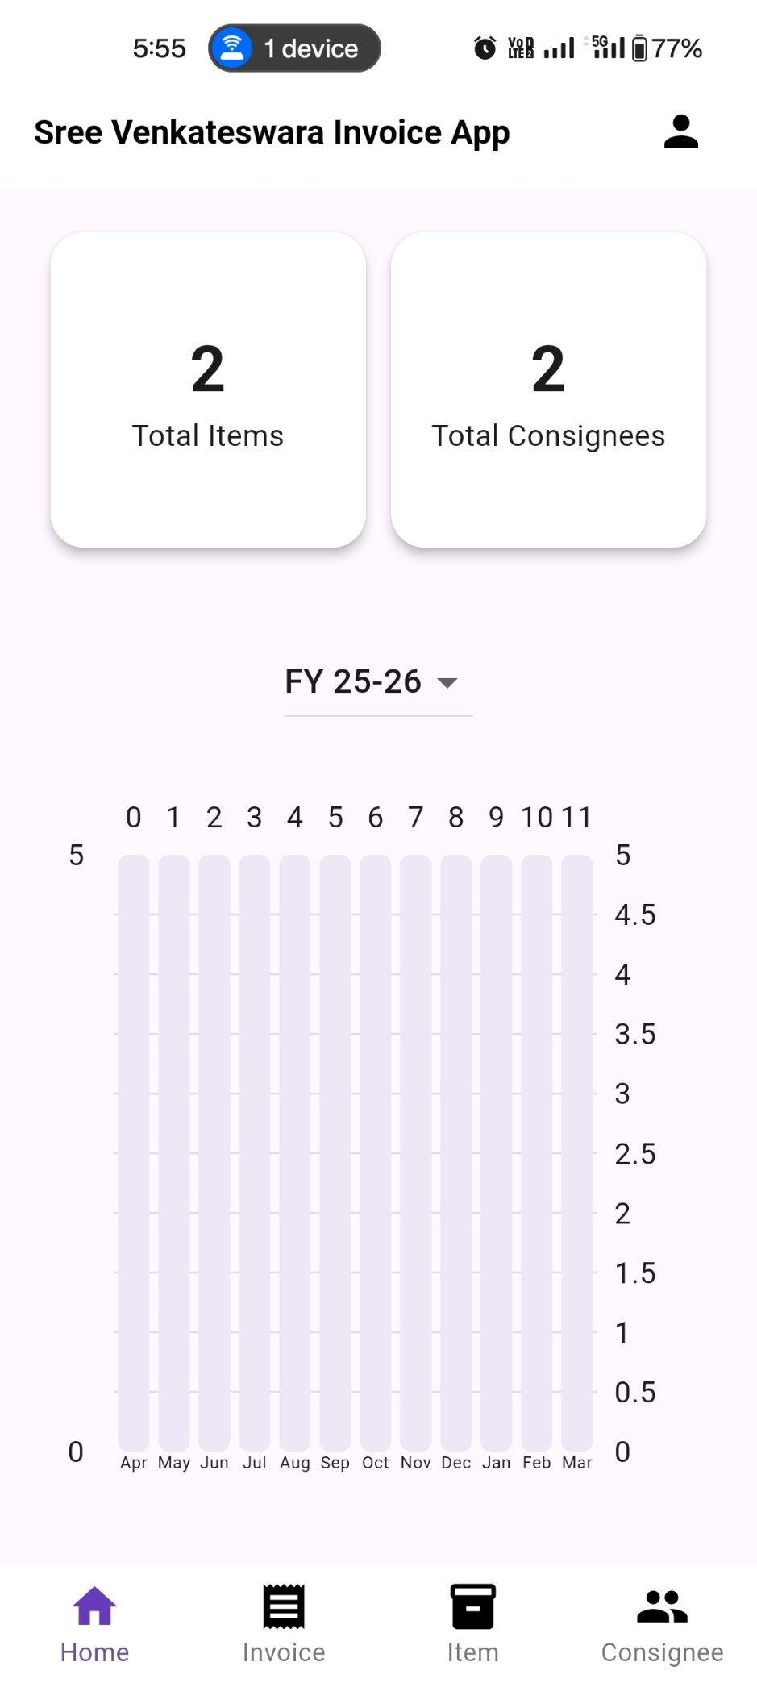

**Fig 2.1**

**Step 2: Add a New Item**

1.Navigate to the Items page from the navigation bar.

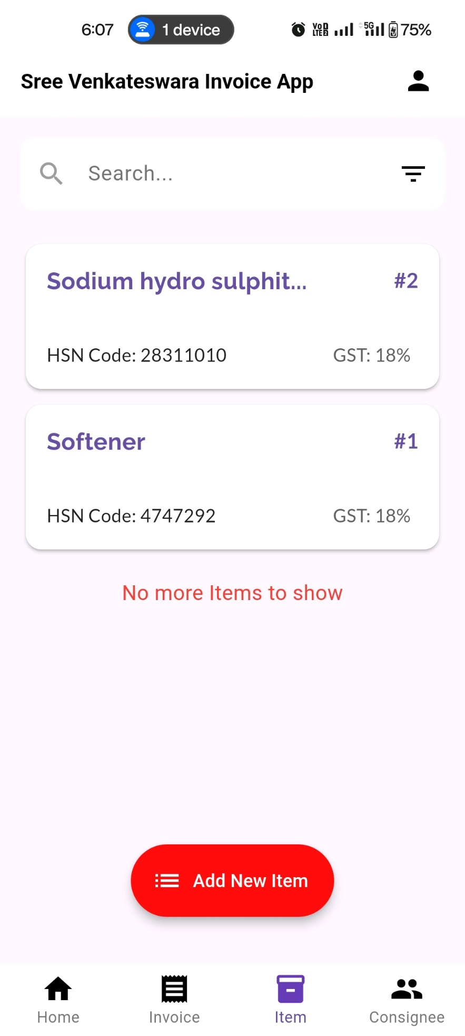

2.Click on Add New Item.

**Fig 2.2**

3.Fill in the item name, HSN code, select UOM and GST

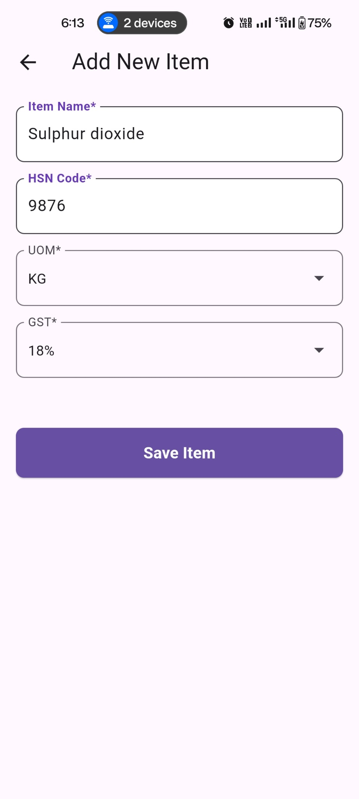

4.Click on Save Item to save the item.

**Fig 2.3**

**Step 3: Add a New Consignee**

1.Go to the Consignee page.

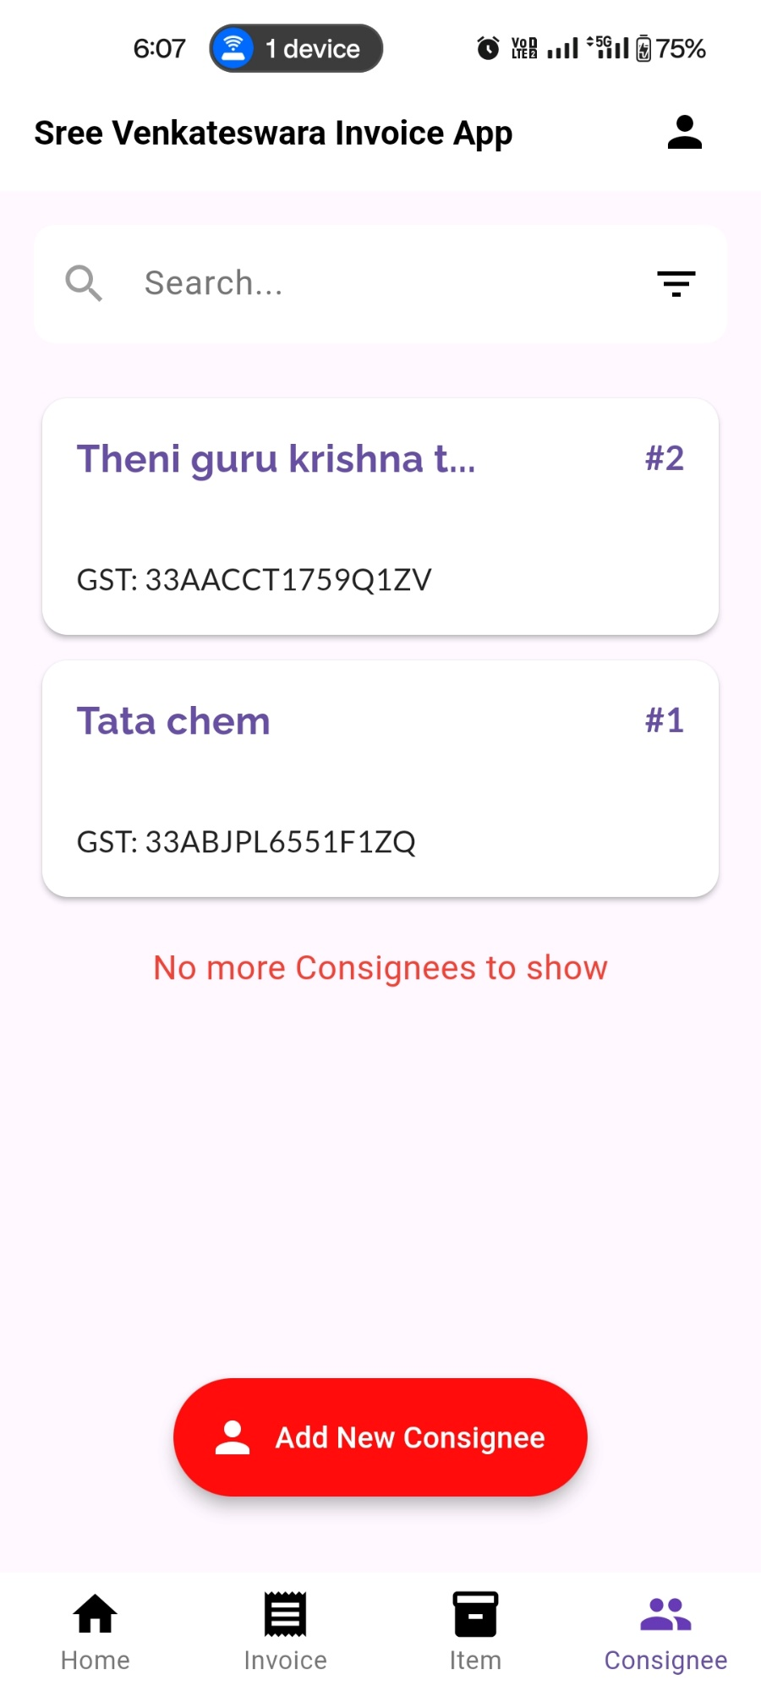

2.Click on Add New Consignee.

**Fig 2.4**

3.Enter the consignee’s name, GSTIN, address, state and based on state the code will get fill

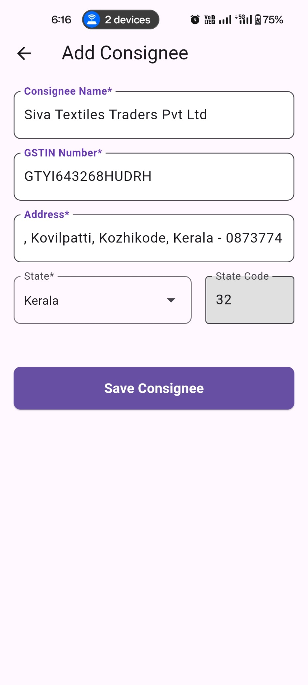

4.Click on save consignee to save consignee details.

**Fig 2.5**

**Step 4: Create Your First Invoice**

1.Navigate to the Invoice page.

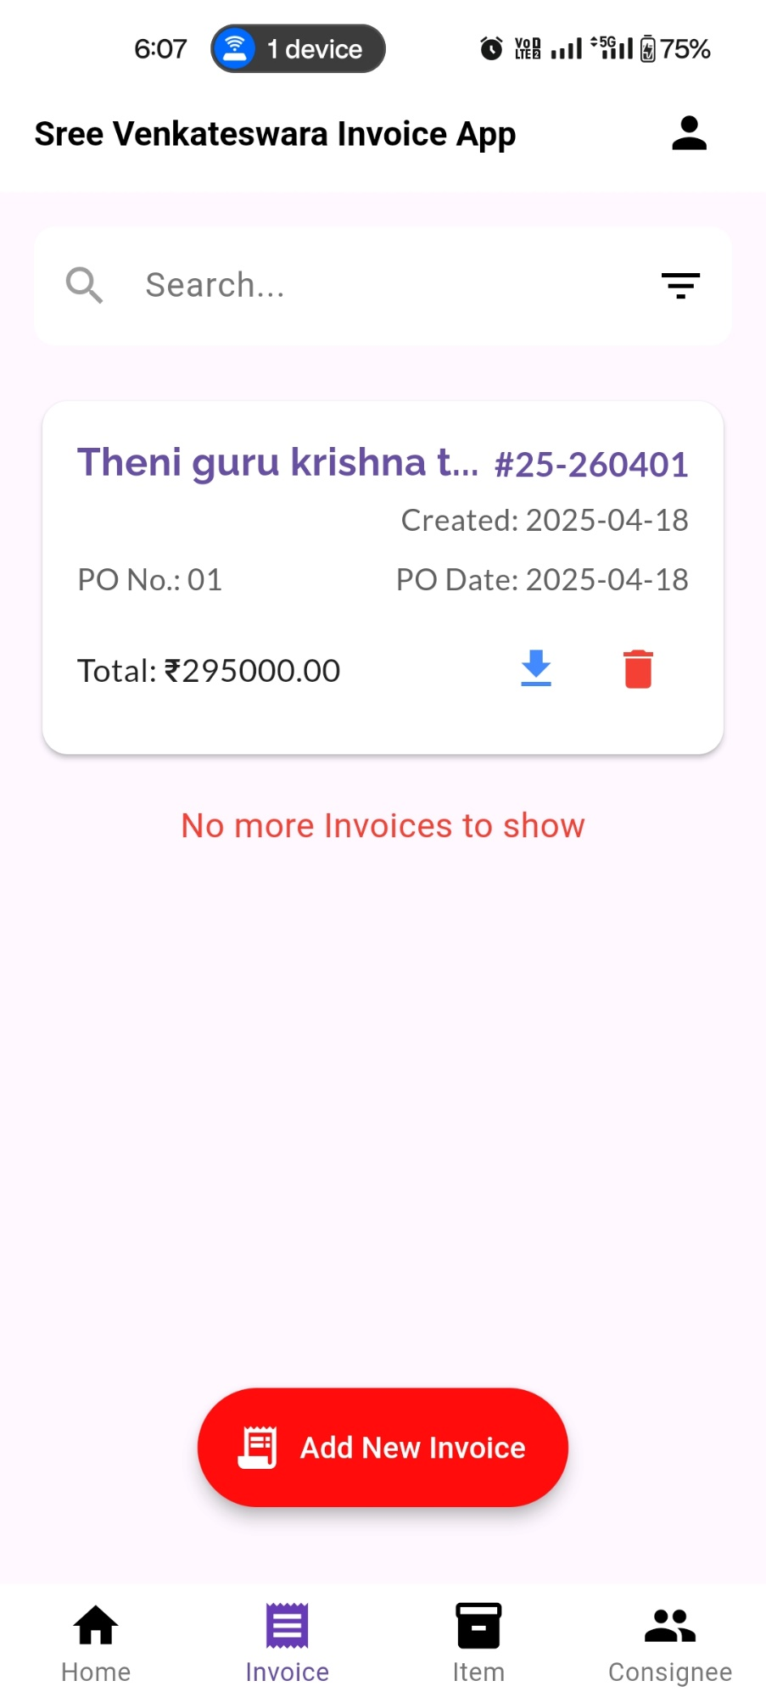

2.Click on Add New Invoice.

**Fig 2.6**

3 Select a Consignee from the dropdown.  
→ The consignee's details will automatically populate, add PO number and PO date

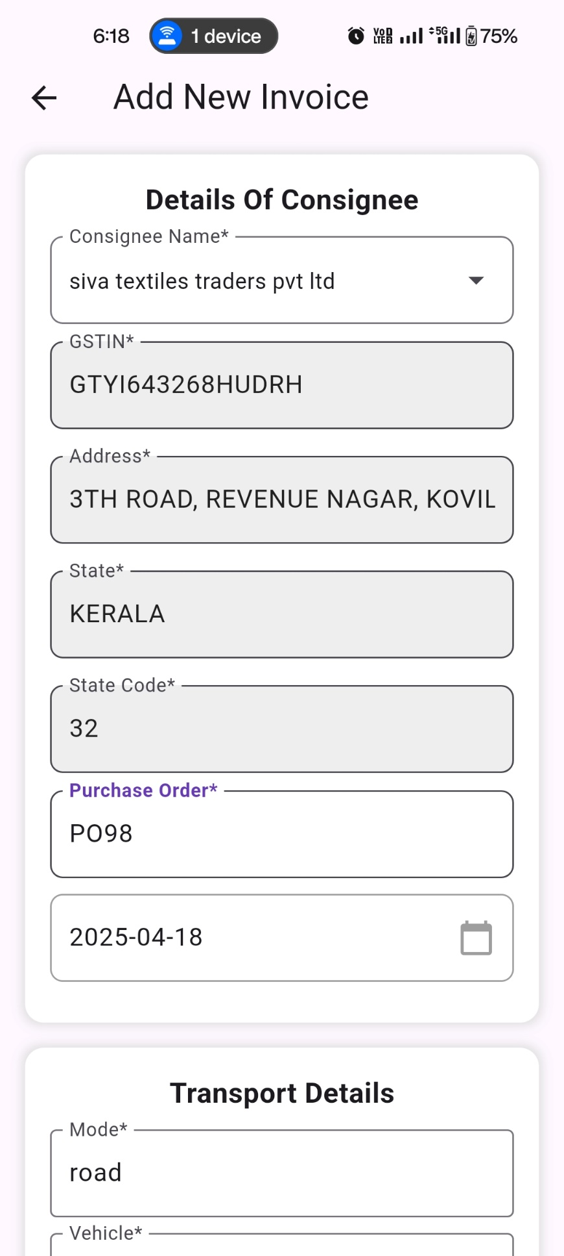

**Fig 2.7**

4.Add Transport Details mode, vehicle number, place of supply, supply date, supply time, E-Way bill.

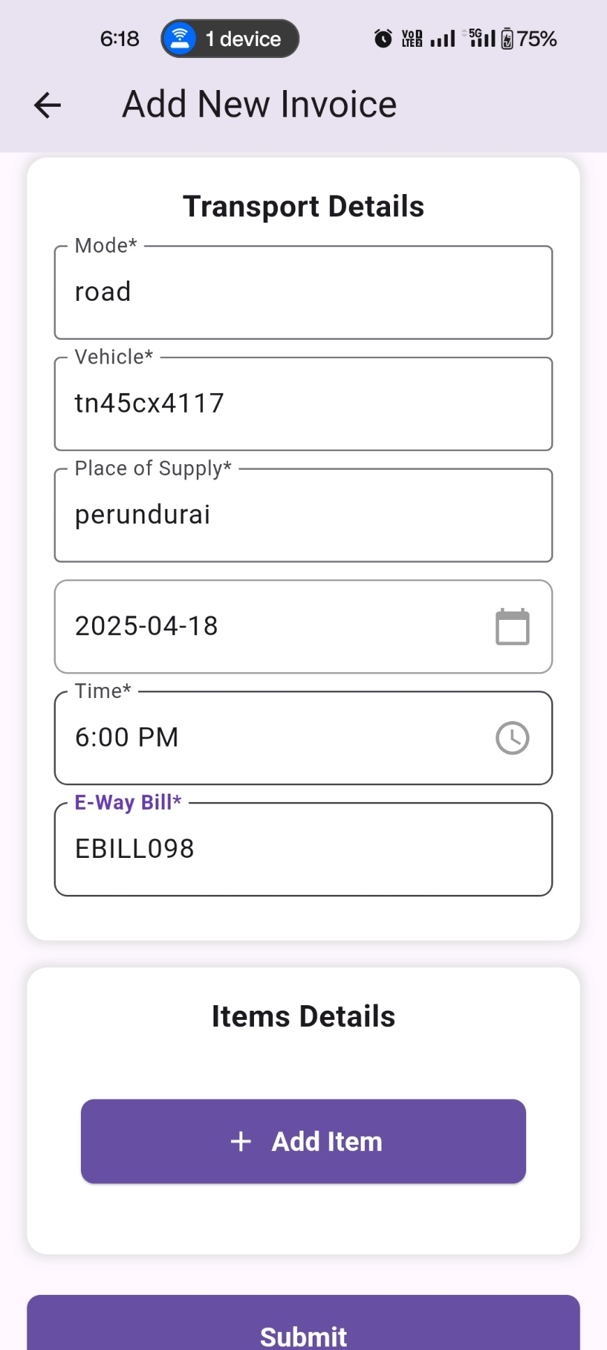

**Fig 2.8**

5.Click Add Item, Select the item, the item details will automatically populate, enter rate and quantity. The bill value automatically calculated.

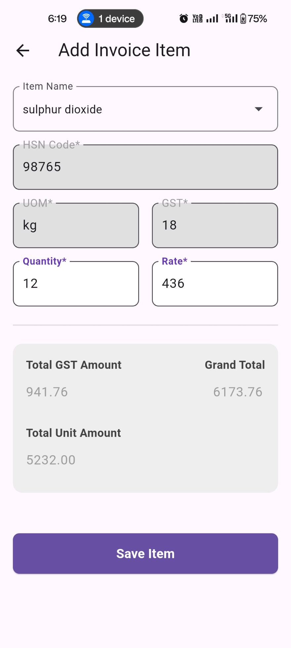

2.Click on Save Item to add item in invoice

**Fig 2.9**

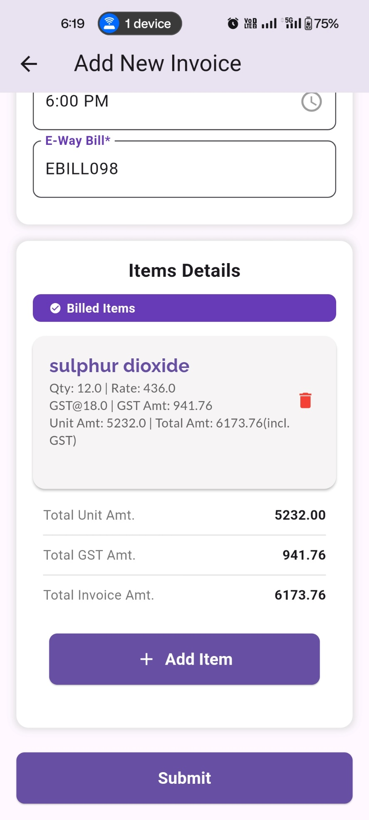

**Fig 2.10**

6.Review the invoice and click Submit. The generated **Invoice PDF** will automatically open up.

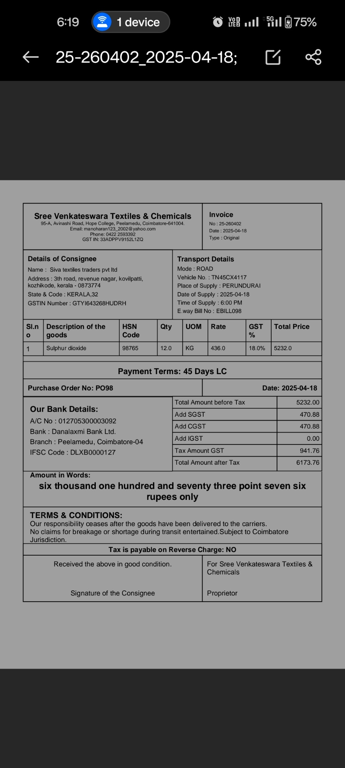

**Fig 2.11**

Congratulations! you have successfully created your first invoice using the SVTC App.

**4.Home Page**

**4.1 Monthly Invoice Statistics**

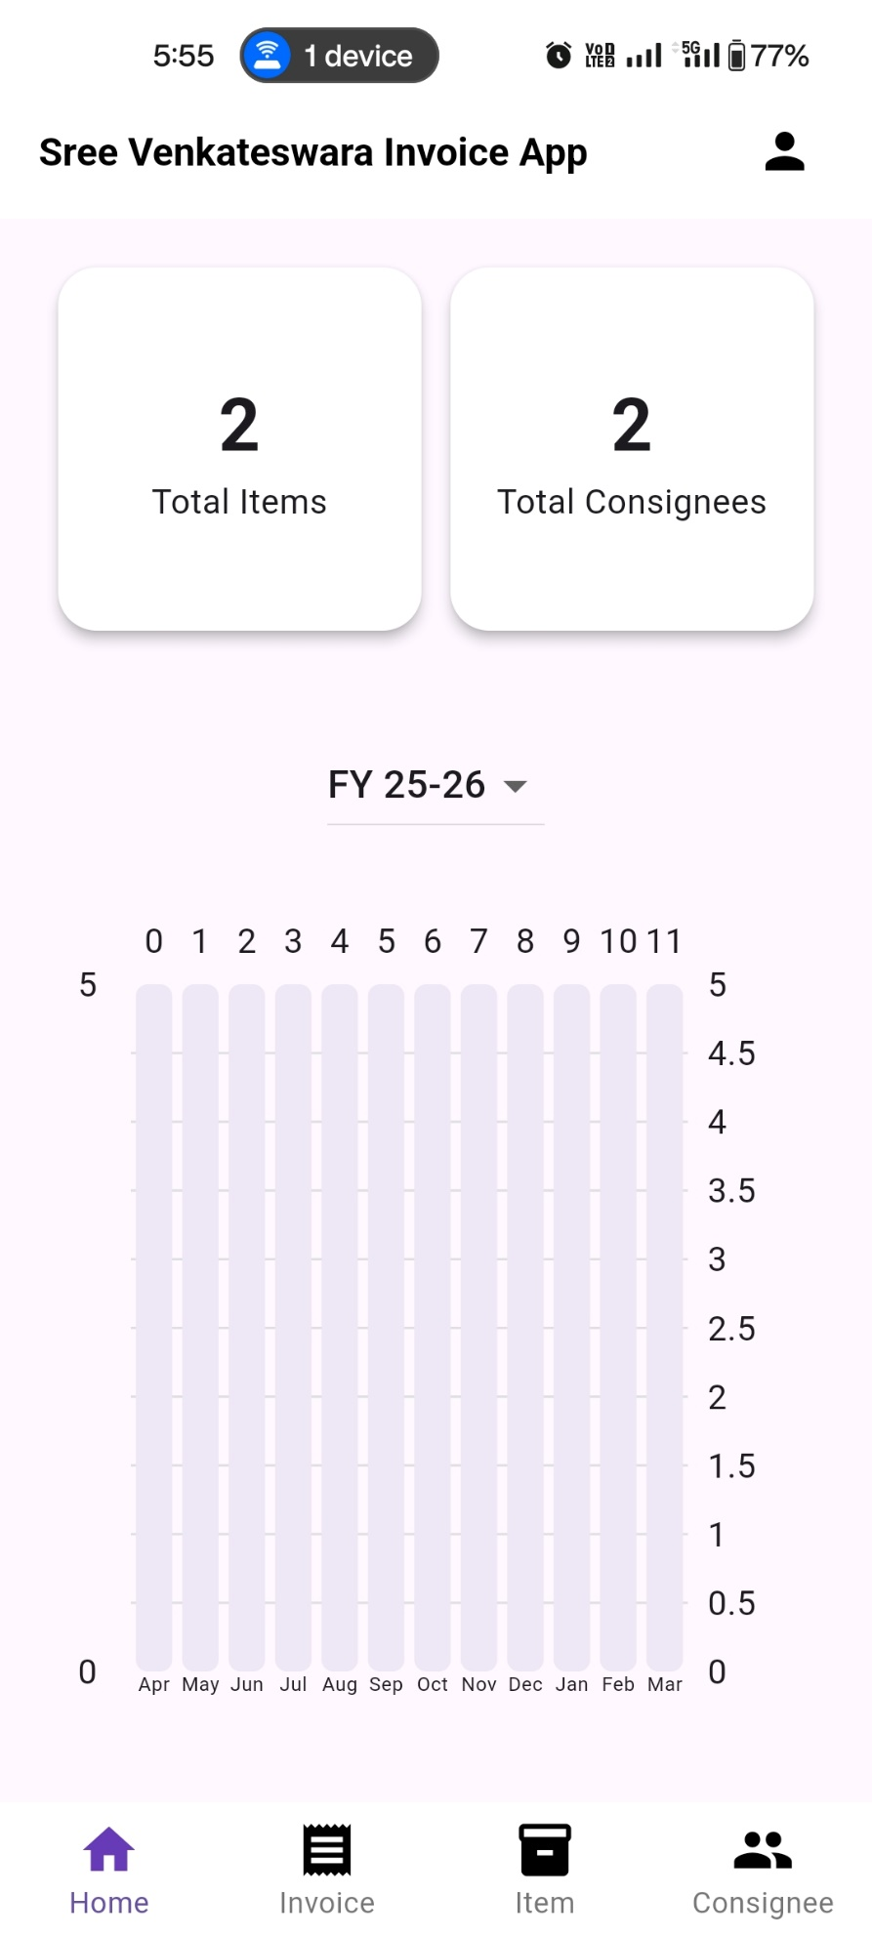

4.Navigate to pages with the navigation bar

1.Total Number of items saved.

3.See number of invoices per month

2.Total Number of Consignees saved.

**Fig 4.1**

**5.Items Page**

**5.1 Adding a New Item**



1.Click on Add New Item.

**Fig 5.1.1**



6.Click on Save Item to save the item.

3.Enter HSN Code

5.Select GST from the dropdown

4.Select UOM from the dropdown

2.Enter Item Name.

**Fig 5.1.2**

**5.2 Update Item Details**



1.Click on Item card to update the item

**Fig 5.2.1**

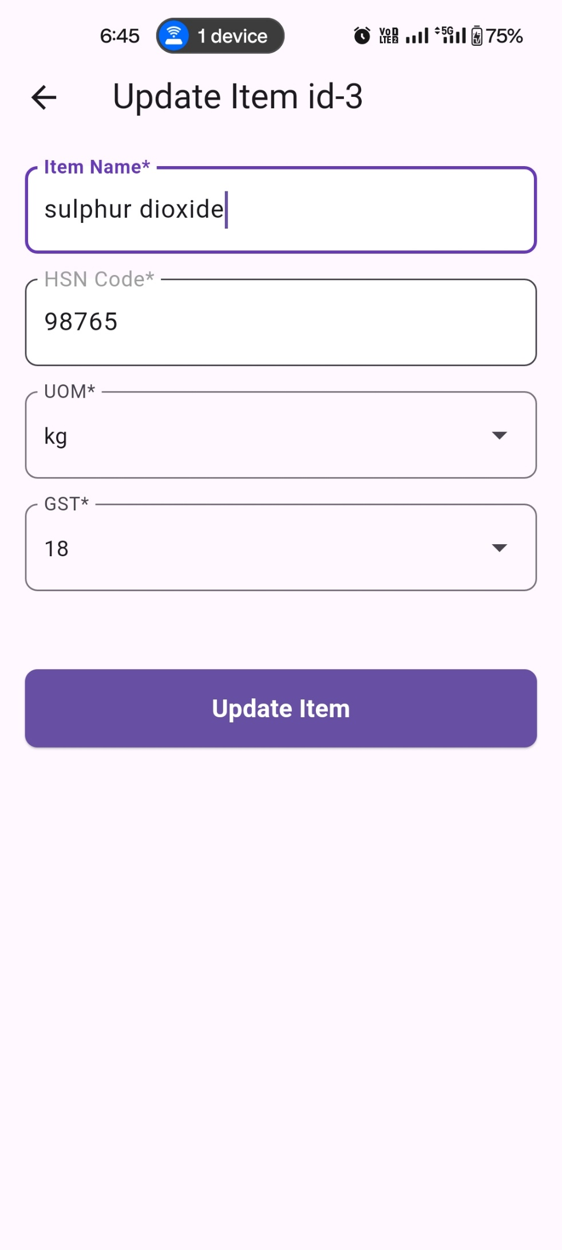

2.Update the item details you wish and Update Item button

**Fig 5.2.2**

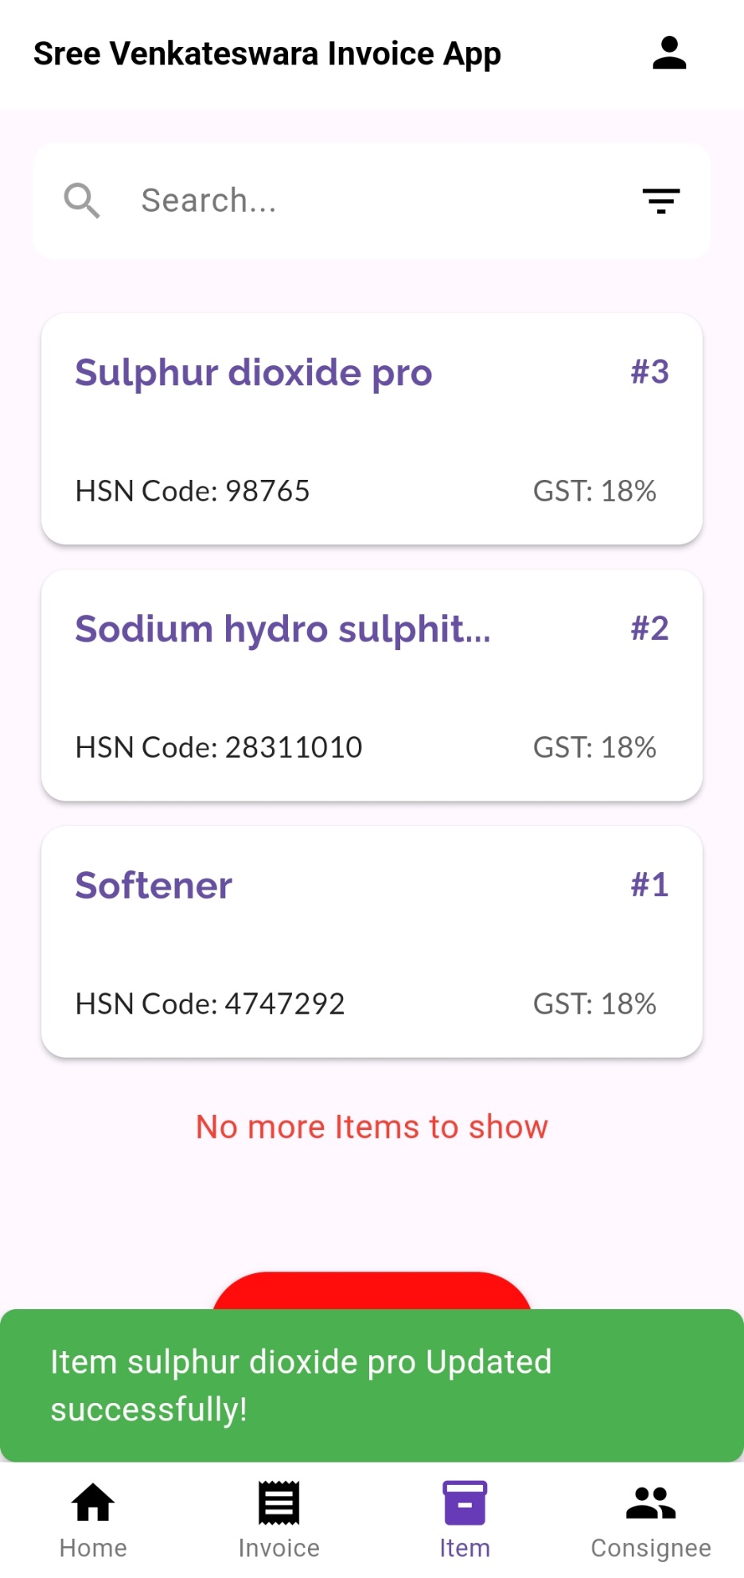

3.You can see a confirmation message of item updated successfully

**Fig 5.2.3**

**5.3 Searching & Filtering Items**

1.Click on the filter icon on search bar

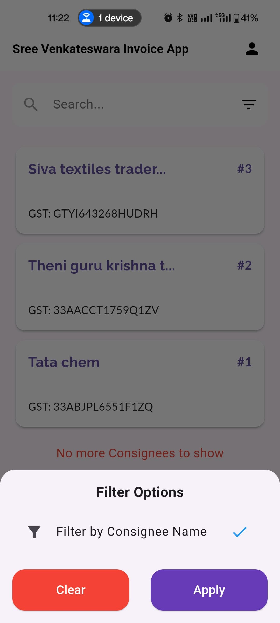

2.Select the filter you wish and click on apply

**Fig 5.3.1**

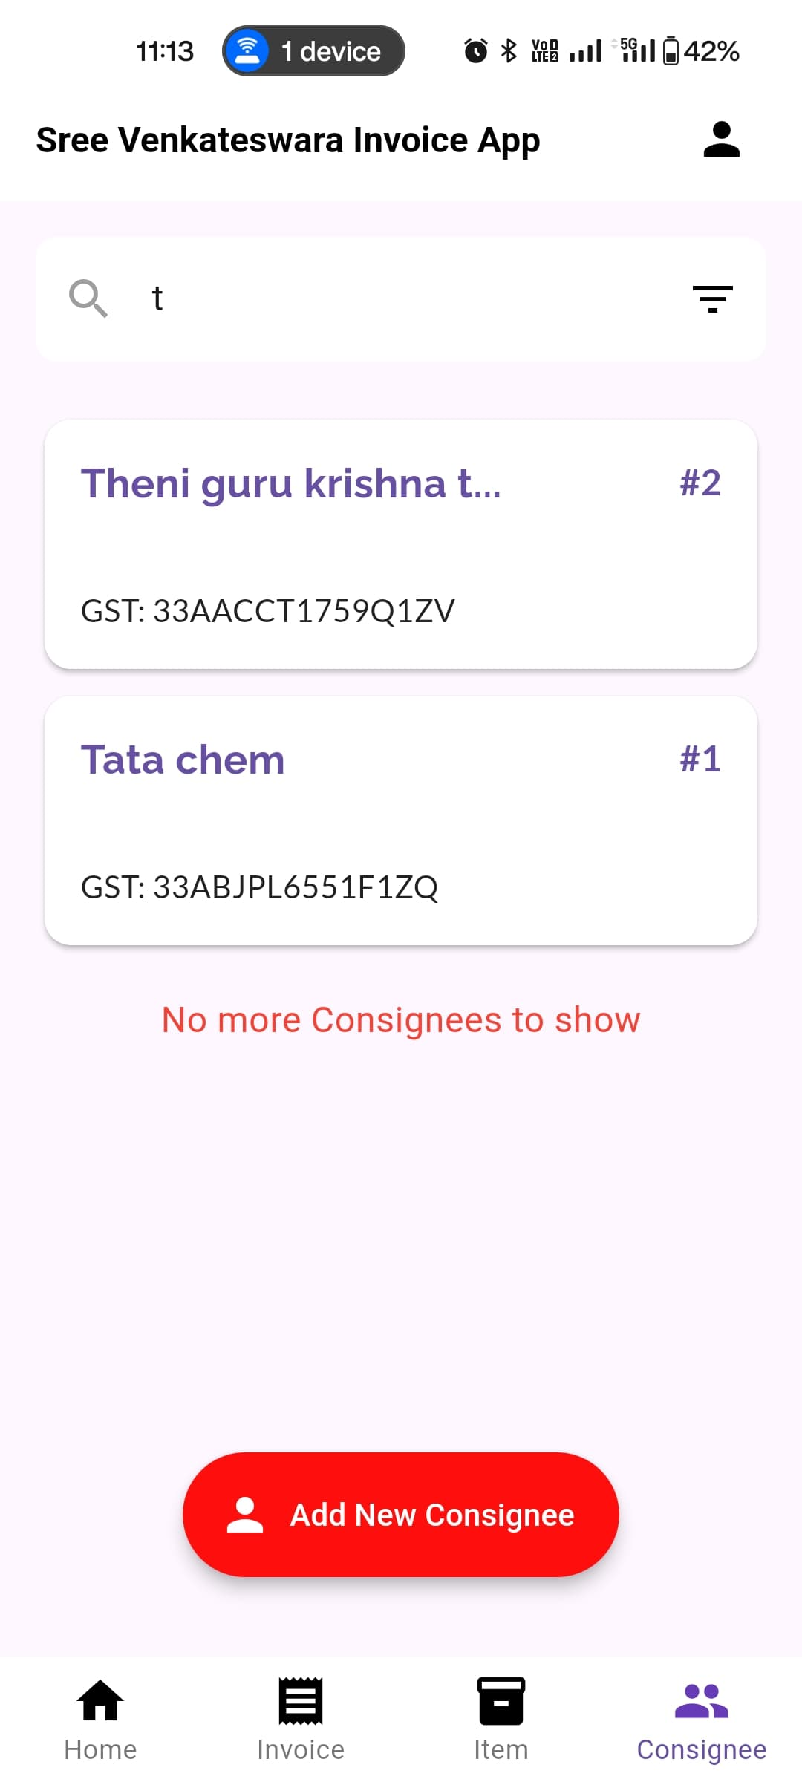

3.Search the item with the filter selected

**Fig 5.3.2**

**6.Consignee Pa**

6.1 Adding a New Consignee

1. Go to the Consignee page.

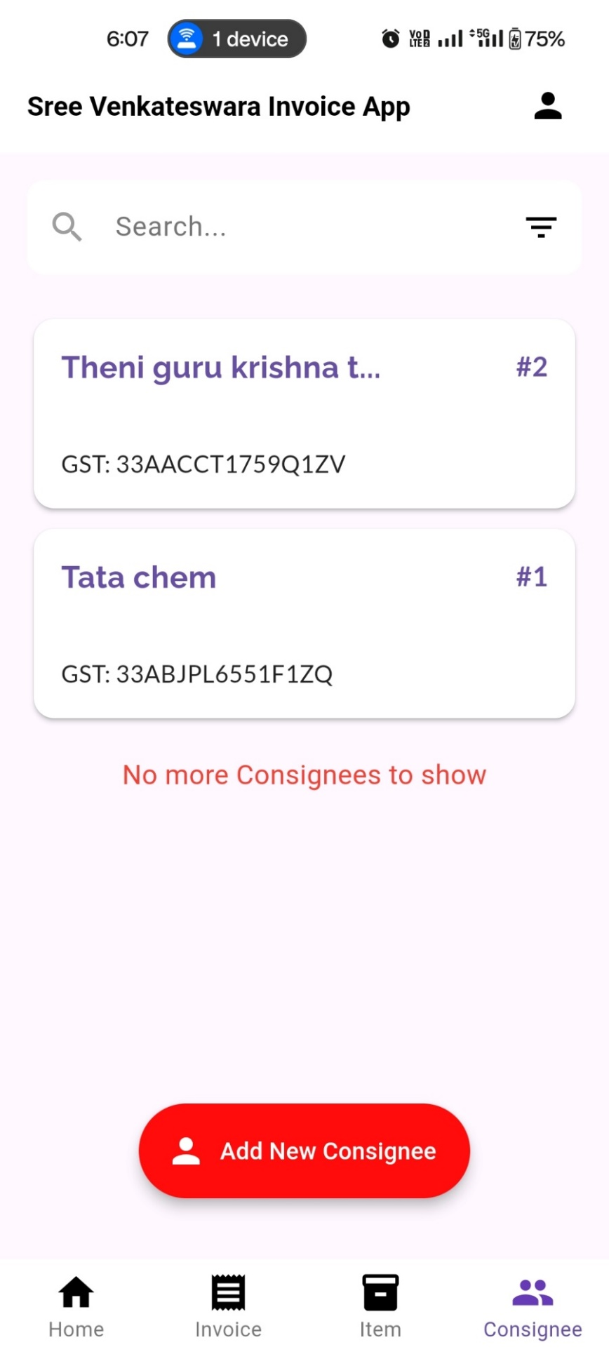

2.Click on Add New Consignee.

**Fig 6.1.1**



5.Entry address

6.Select State

4.Entry GST number

3.Entry Consignee Name

8.Click on save consignee to save consignee details.

7.Click on save consignee to save consignee details.

**Fig 6.1.2**

**6.2 Updating Consignee Details**

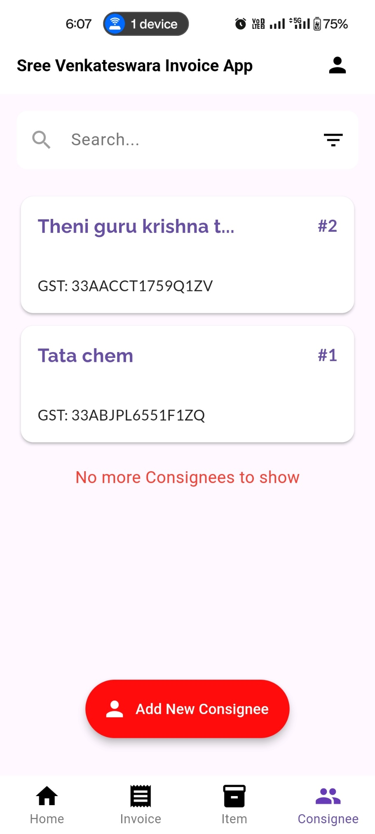

1.Click on Consignee card to update the Consignee

**Fig 6.2.1**

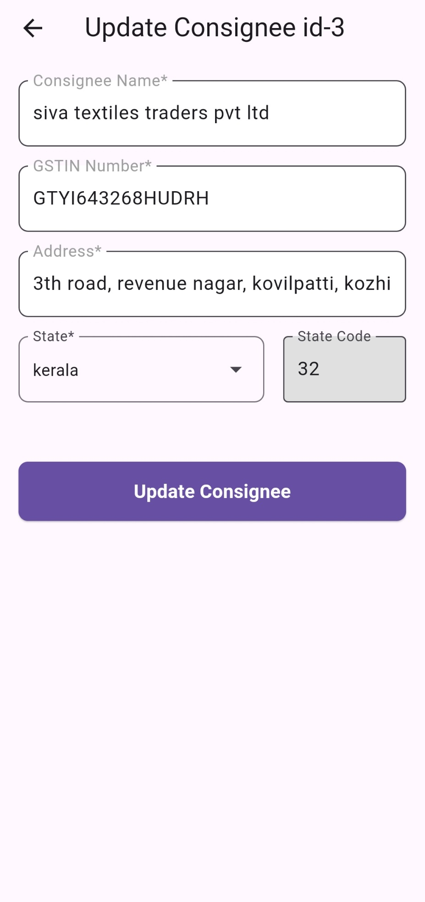

2.Update the consignee details you wish and click Update consignee button

**Fig 6.2.2**

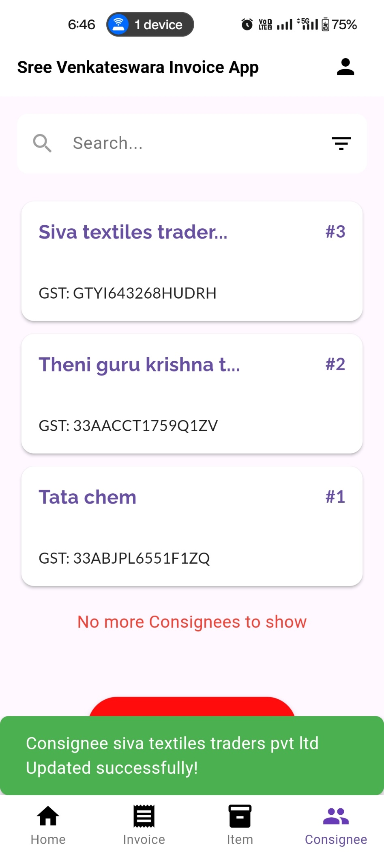

3.You can see a confirmation message of consignee updated successfully

**Fig 6.2.3**

**6.3 Searching & Filtering Consignee**

1.Click on the filter icon on search bar

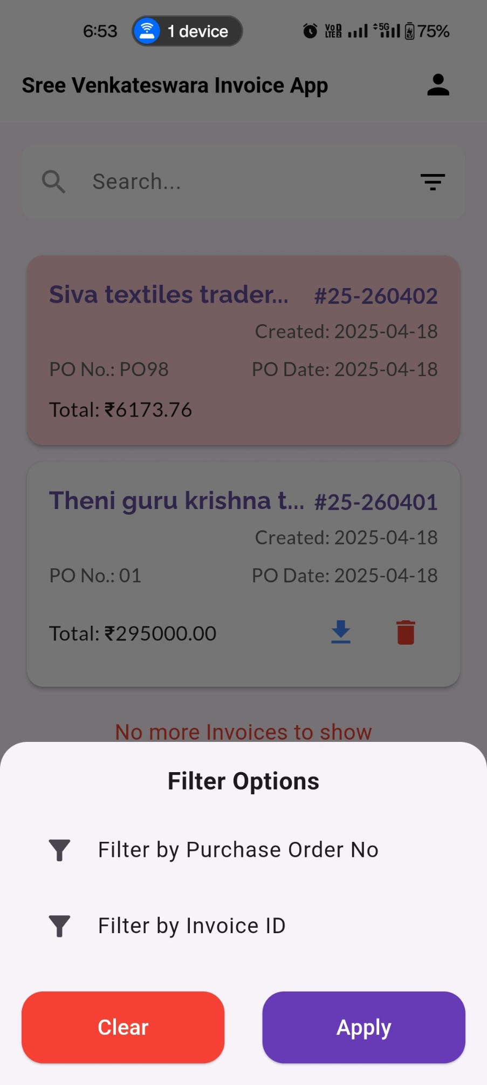



2.Select the filter you wish and click on apply

**Fig 6.3.1**

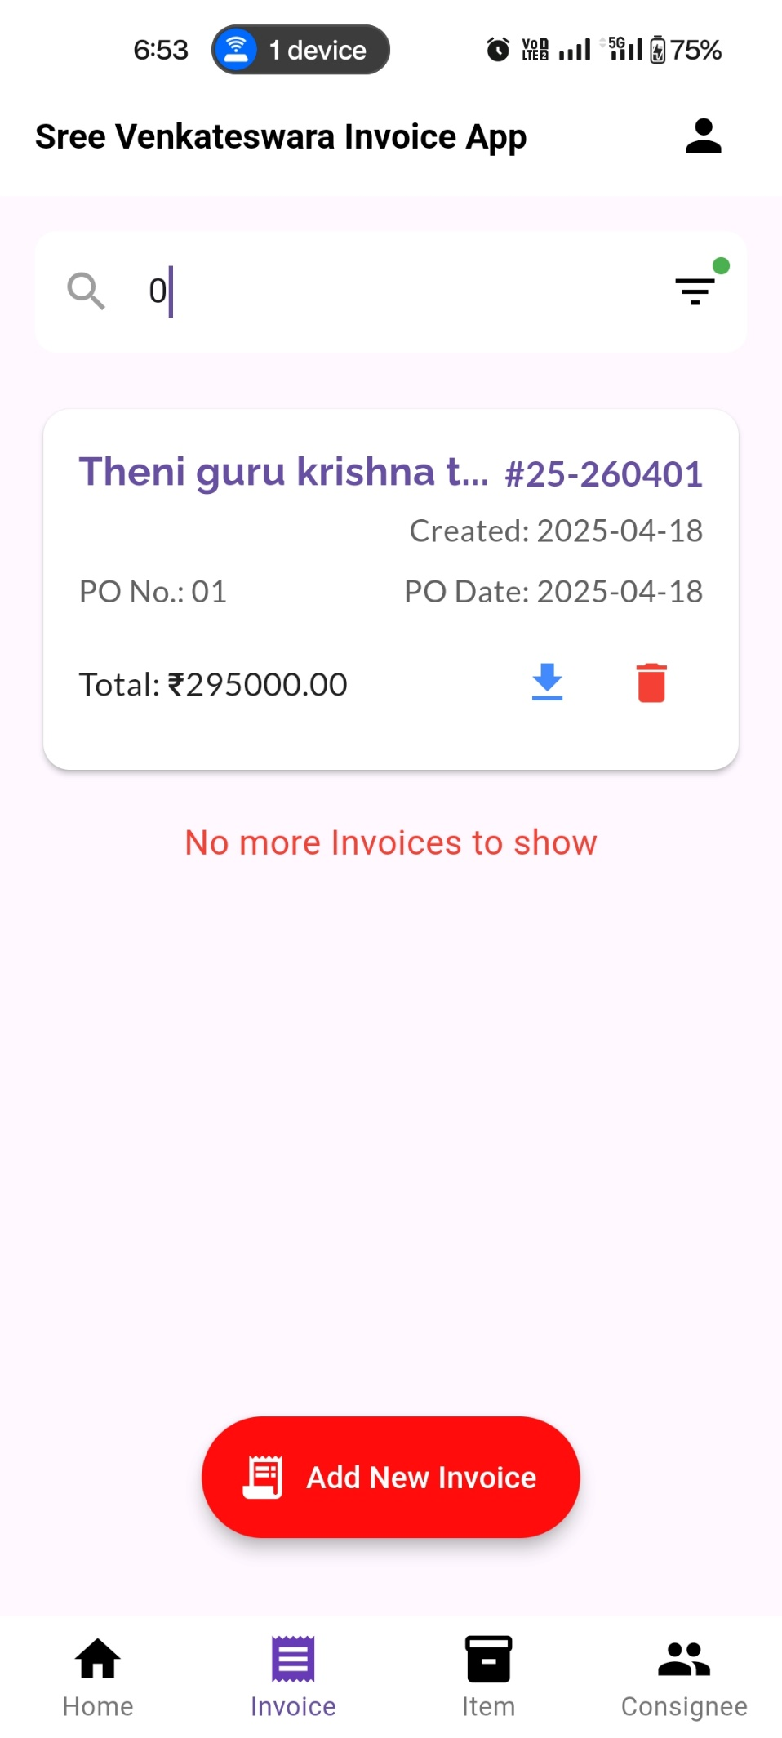

3.Search the Consignee with the filter selected

**Fig 6.3.2**

**7.Invoice Page**

**7.1 Creating a New Invoice**

1.Navigate to the Invoice page.

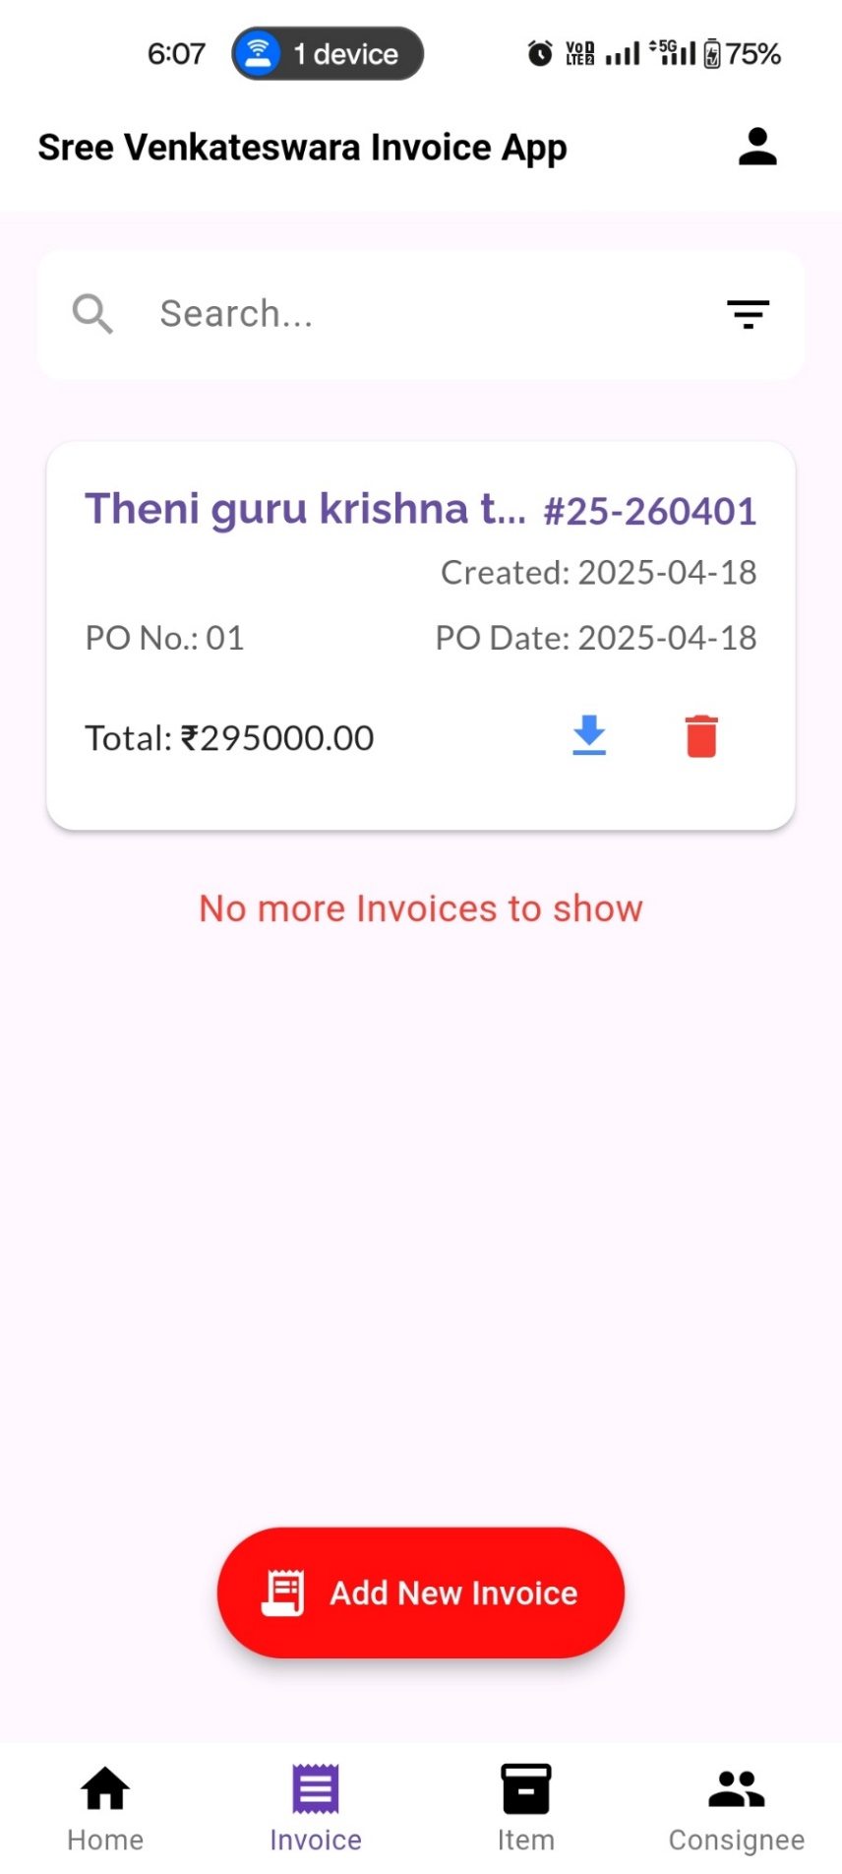

2.Click on Add New Invoice.

**Fig 7.1.1**



3 Select a Consignee from the dropdown.

→ The consignee's details will automatically populate, add PO number and PO date

**Fig 7.1.2**



10.Click on Add items to add item to invoice

7.Select date of supply

6.Entry Place of supply

5.Entry Vehicle number

9.Entry E-Way Bill

8.Select time

4.Entry Mode

**Fig 7.1.3**

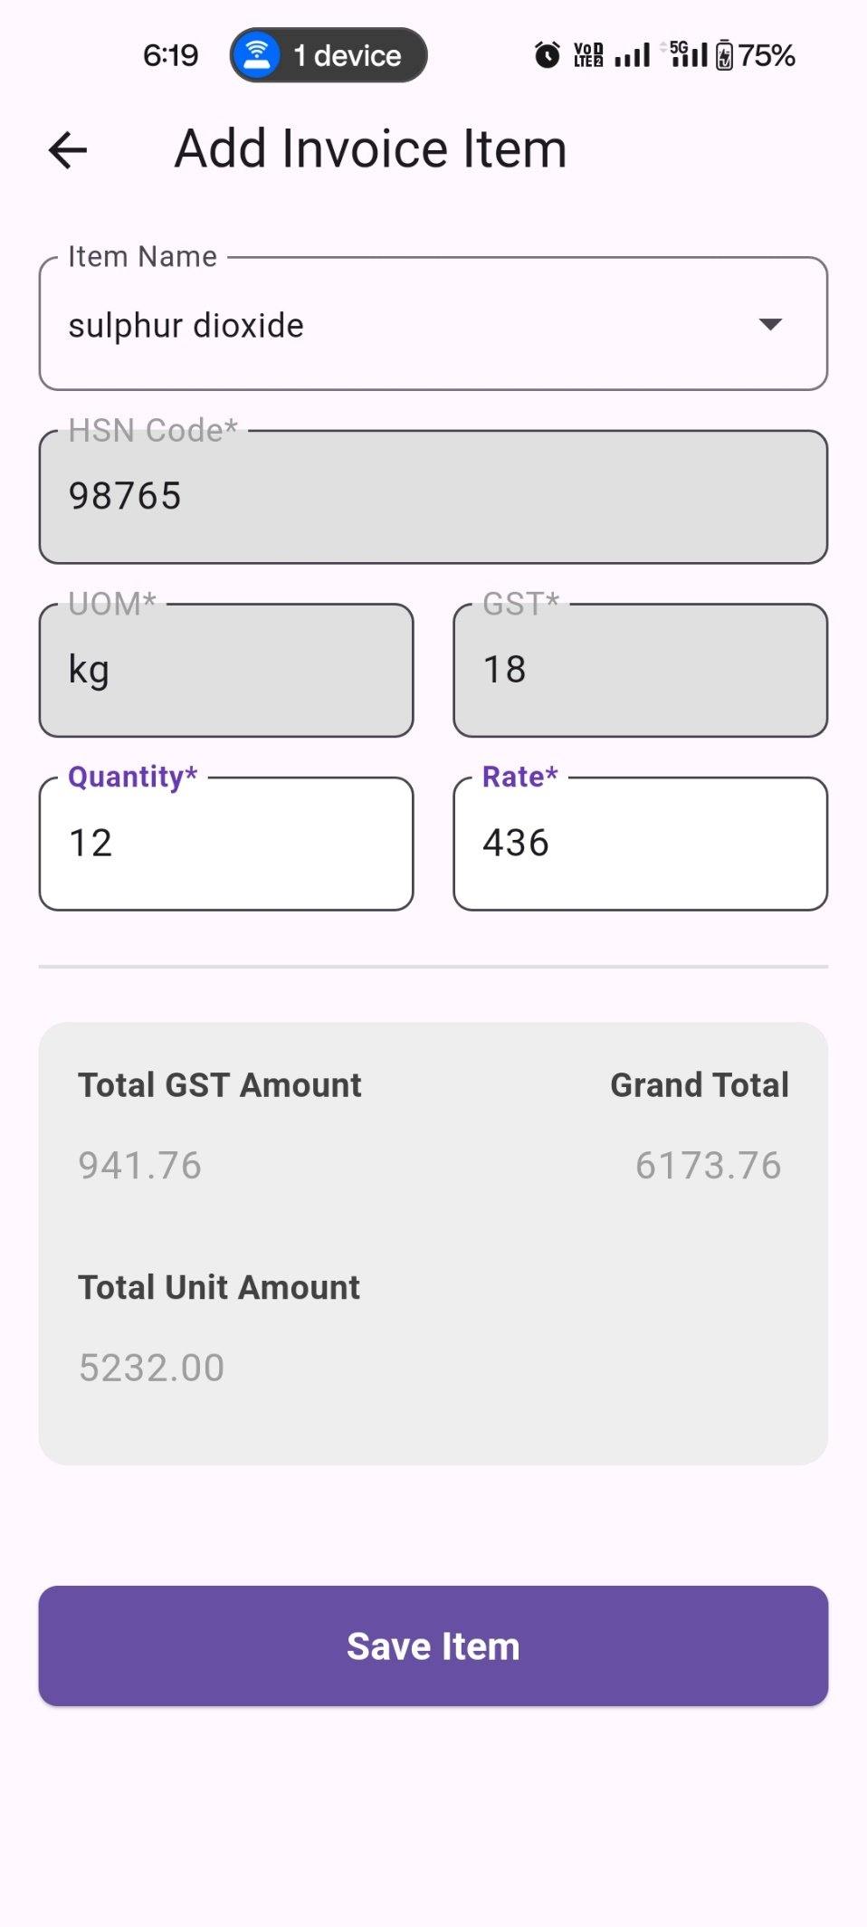

15.Total GST, Total Unit Amount and Grand Total will automatically

calculated

13.Entry item Quantity

14.Entry item Rate

11.Select an item from the dropdown you wish to add

12.the item details will automatically populate

16.Click on save item to add item in invoice

**Fig 7.1.4**



19. Review the invoice and click Submit. The generated **Invoice PDF** will automatically open up.

18.Click on add item to add item more items in invoice

17.The saved item show in the list

**Fig 7.1.5**



**Fig 7.1.6**

20. This is the generate invoice pdf

**7.2 Searching & Filtering Invoice**

1.Click on the filter icon on search bar



2.Select the filter you wish and click on apply



**Fig 7.2.1**



3.Search the Invoice with the filter selected

**Fig 7.2.2**

**7.3. Deleting Invoice**

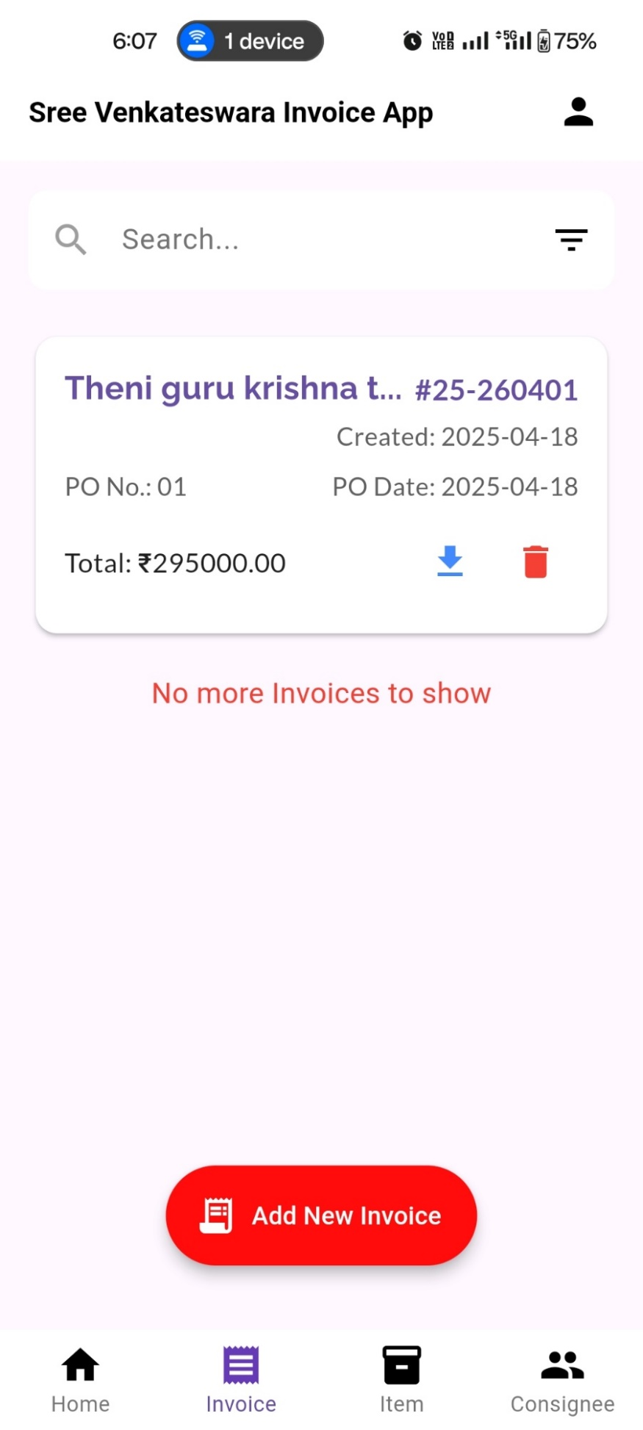

1.Click on delete button to disable the invoice

**Fig 7.3.1**

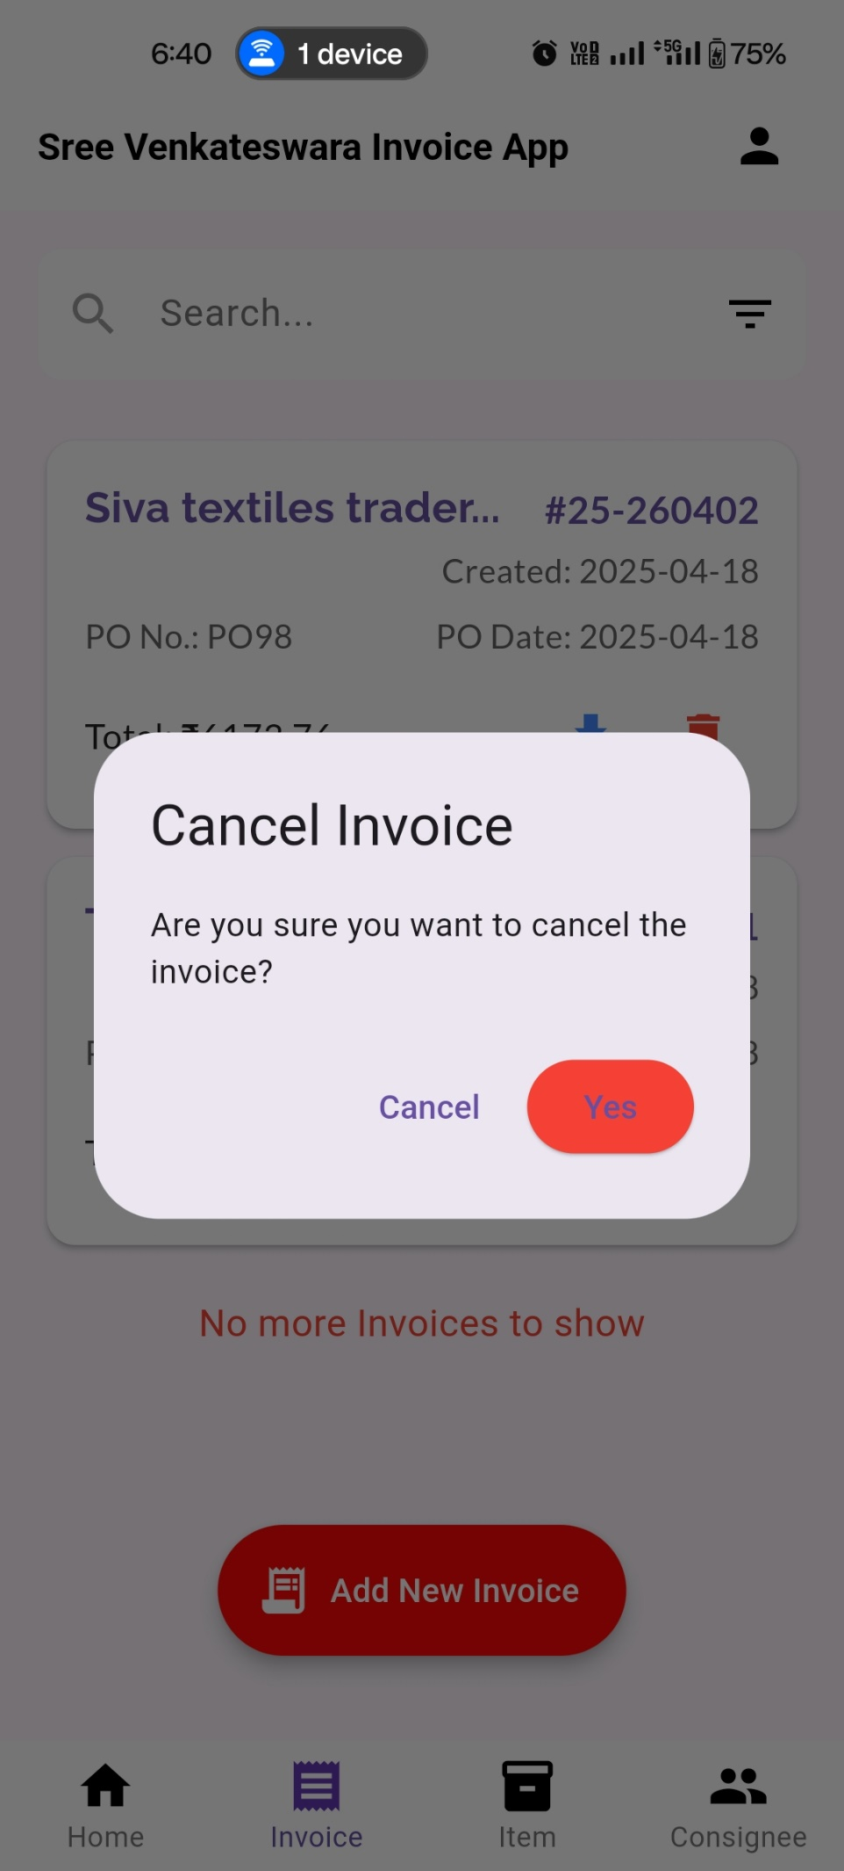

2.If you want to delete invoice then click yes else Cancel

**Fig 7.3.2**

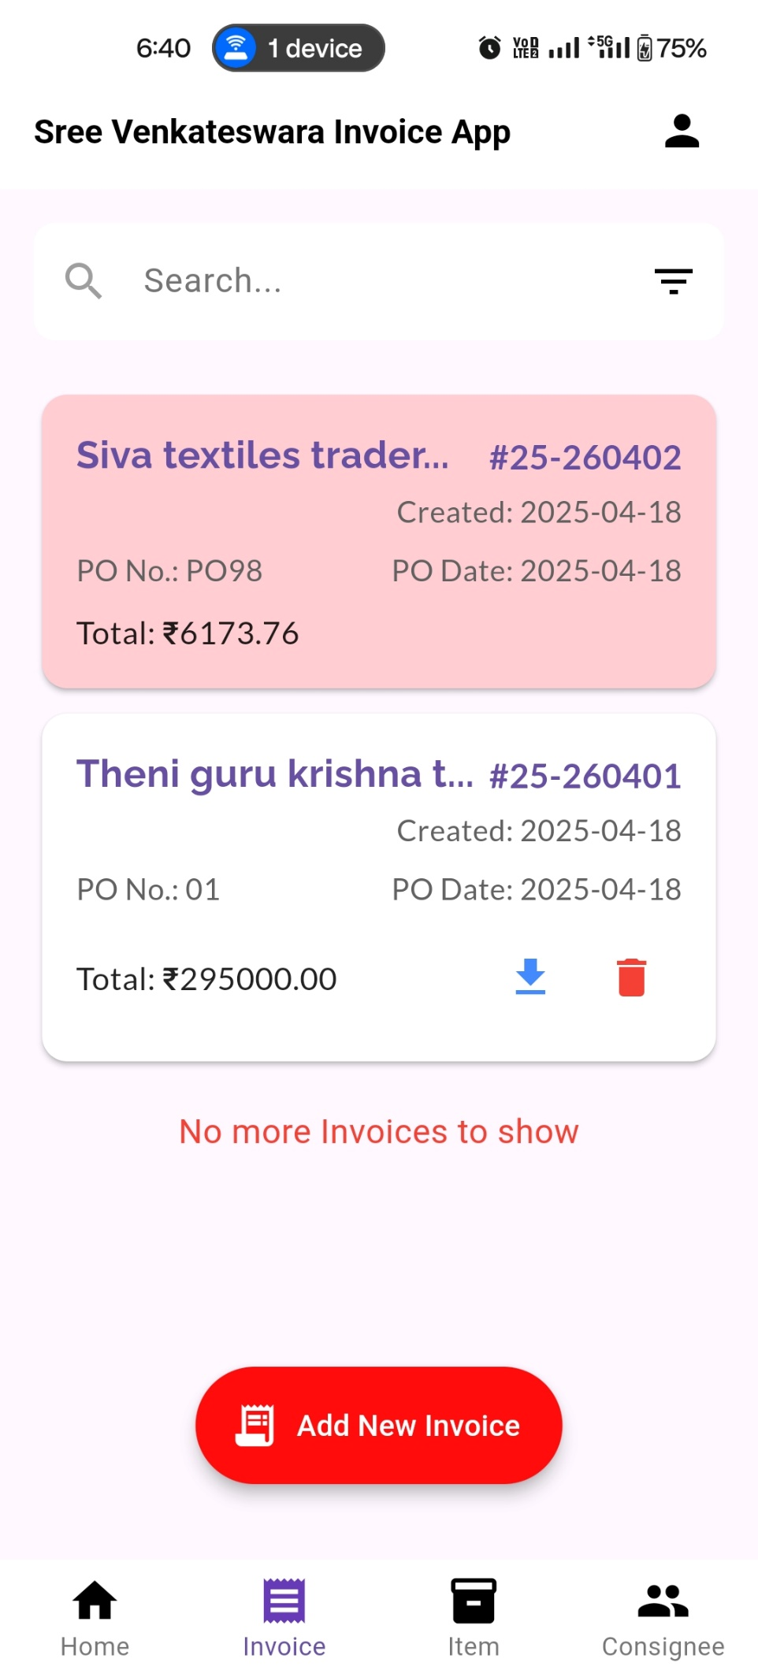

3.the invoice get disabled now you cannot download this invoice

**Fig 7.3.3**

**7.4 View and Downloading Invoice**



1.Click on download icon to view and download invoice

**Fig 7.4.1**

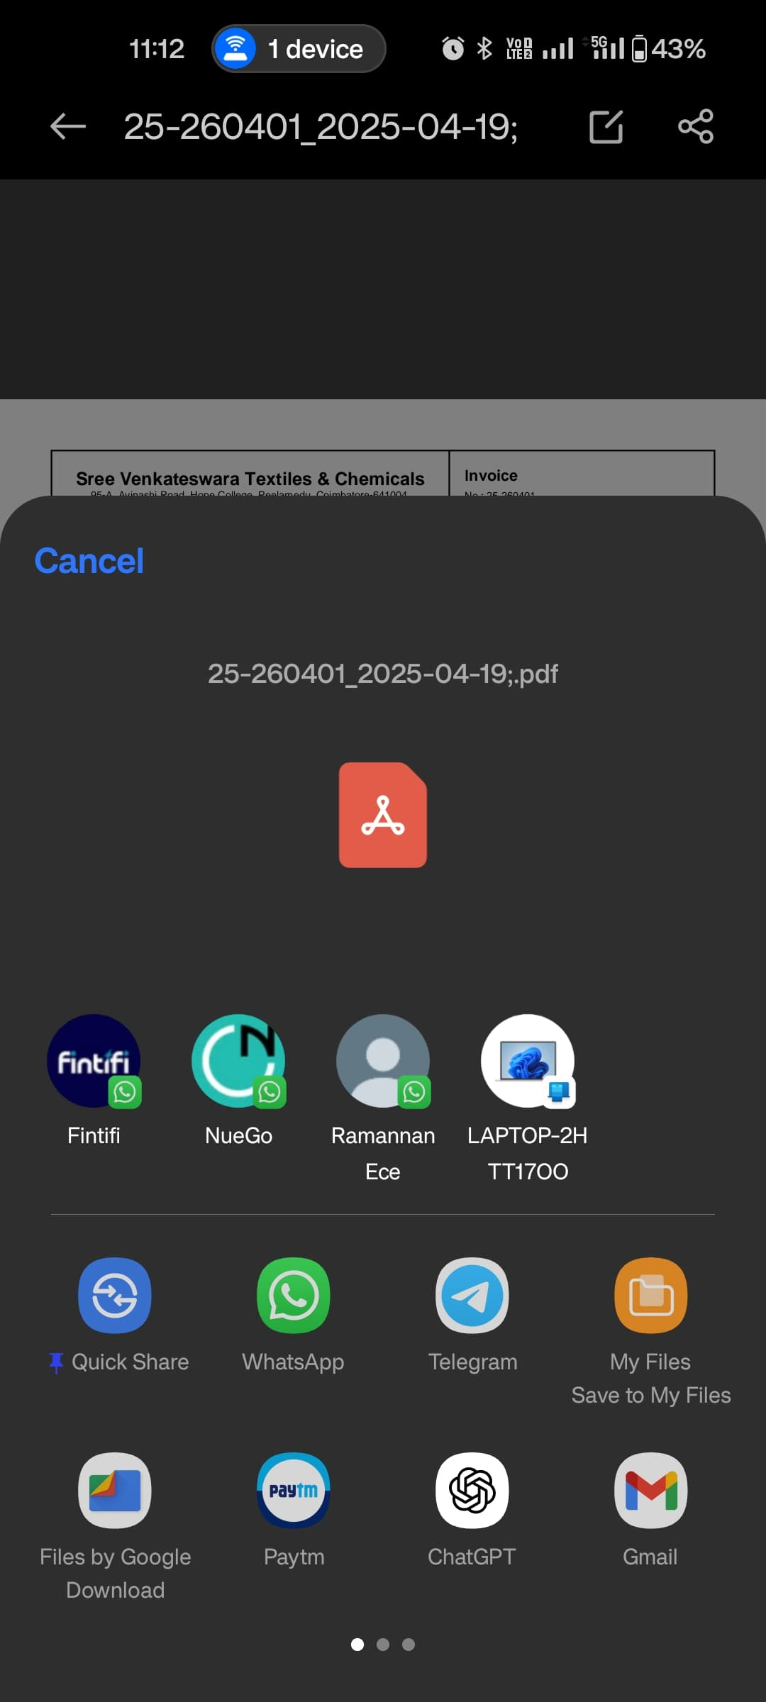

2.Select the option to view, download and share the invoice

**Fig 7.4.2**

**8.Support & Contact Information**

For help or to report an issue, contact:  
**Email**: swarmedtech@gmail.com  
**Phone**: +9629437702

**Website**: https://sreevenkateswara.pythonanywhere.com/